**Name : Yumna Mubeen**

**F.Name : Muhammad Nadeem**

**Section : A**

**Seat no. : B21110006165**

**Field : BSCS (4th Sem)**

**Course : Mathematics IV (Numerical Computing) (406)**

**Teacher : Ma’am DR Noor Fatima Siddiqui (NFS)**

**Assignment :**

**MATLAB Code For Least Squares Approximation :**

**For Straight Line :**

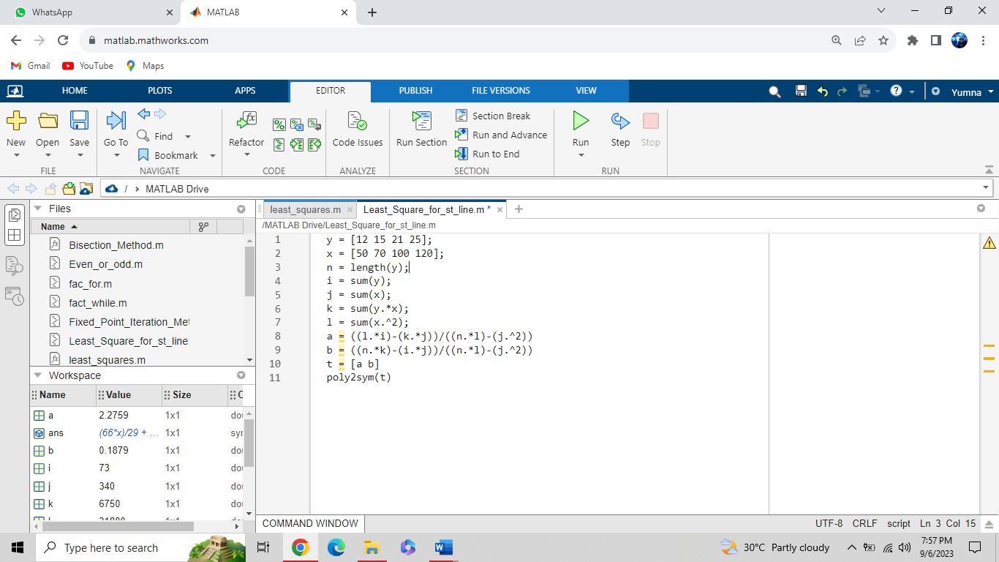 **Output :**

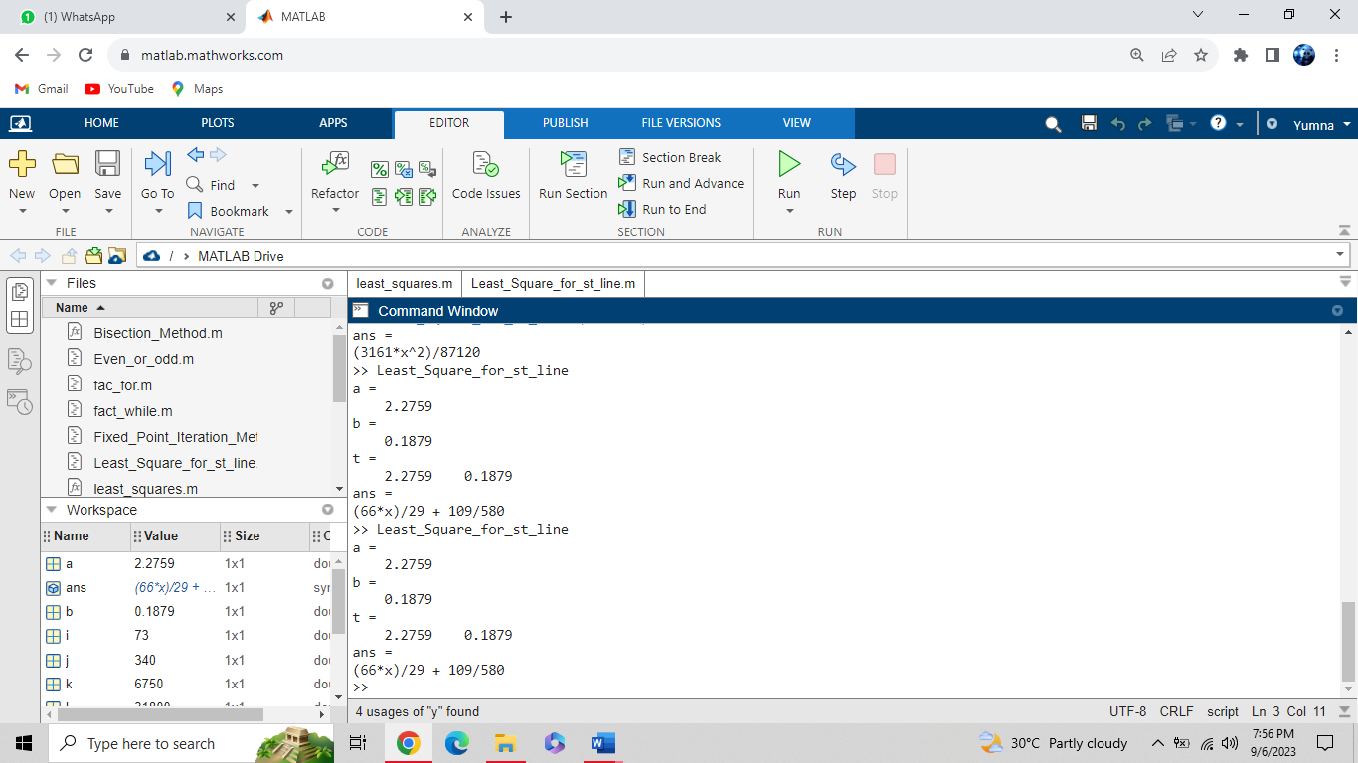

**For Parabola :**

